

DealManager™

User Guide

Prepared By:

Jonathan Kingsepp

TABLE OF CONTENTS

Overview of DealManager 5
Installation 6
DealManager 6
Configurator 6
Database Connectivity 6
Asset DLL 6
Primary Features 6
Expressions Stored in the Database 6
Eligibility Criteria Stored in the Database 6
Expandable Database 6
Automated Report Generation 6
Standard and Custom Report Engine 6
Main Screen 7
Create Global Asset Expressions 8
Creation of New Asset Expressions 10
Editing and Deleting Existing Asset Expressions 10
Create Global Custom Concentration Expressions 11
Creation of New Custom Concentration Expressions 11
Editing and Deleting Existing Custom Concentration Expressions 13
Deals 14
Create New Deal 16
Copy Existing Deal 16
View Deal Information 16
Configure Deal 16
Select Deal 16
Define Deal Inputs 17
Define Deal Tests 21
Define Eligibility Criteria 23
Define Standard Concentration Criteria 24
Apply Custom Concentration Criteria 26
Pools 27
Assets 27
Create Pool 28
Active Pools 31
View 31
Assets 31
Inactive Pools 31
View 31
Activate 31
Rebalance 32
Delete 32
Eligibility Criteria 33
Standard Concentration Criteria 34
Custom Concentration Criteria 35
Assets 36
Pool Generation Logs 36
Deal Reports 38
Deal Data Reports 38
Create New Data Report 39
Edit or Delete Existing Deal Data Report 42
Generate Deal Data Report 43
Deal File Vault 43
View Deal Report Files 44
Add Deal Report File 44
Open Deal Report File 44
Update Deal Report File 44
Delete Deal Report File 44
Servicer Report 45
SR Overview 45
SR Common Elements and Categories 45
Exported Data 45
Data Consolidation and Data Formulas 46
Data Reports 46
SR Data Types 46
Inputs 46
Deal Tests 46
Calculated Inputs 46
Key Deal Indicators 47
SR Application 47
Worksheet Navigation 47
Insert Existing Report Worksheet, If Any 48
Deal Test Columns In Report Worksheet 48
Format Custom Worksheets 48
Report Settings 48
Configure Deal Tests 49
Configure Key Deal Indicators 50
Configure Calculated Inputs 50
Check For Deal Test Formula Errors 50
Check For Deal Test Violations 50
Update “Tests” Worksheet 51
Upload Deal Test Data To DMDB 51
Upload KDI & CI Data To DMDB 51
Create Trial Report 51
Create Final Report 51
DM Reports 52
Standard Reports 52
Custom Reports 52
Standard Portfolio Reports 52
View Portfolio Reports 52
Refresh Portfolio Reports 52
Data Reports and File Vault 52
APPENDICES 53
Appendix 1 – High Level Architecture 53
Appendix 2 – Terms and Definitions 54
Appendix 3 – Standard Asset Expressions 55
Appendix 4 – Listed Database Fields 56
Appendix 5 – Standard Custom Concentration Expressions 58
Appendix 6 – Data Elements 59

Overview of DealManager
DealManager™ (DM) by NorthBound Solutions, Inc. (NBS) is a configurable software application designed to meet the selection, audit, calculation and reporting requirements of any Securitization or Structured Finance transaction. DM focuses primarily on the underlying collateral pool, which serves as the collateral behind the Securitization transaction. The user is able to configure DM to reflect all the eligibility, concentration and performance criteria of the underlying securitized assets, as these requirements are defined in the Securitization transaction documents and interpreted by the user. Once configured, the DM selection algorithms identify the maximum amount of assets that comply with all requirements and places them into a securitized “pool” of assets.

Information is loaded into the DM application on a periodic basis through a series of custom load routines that are created to reflect the unique requirements of each customer. Once the data is loaded, the user is able to create and apply the selection criteria required to support the securitization transaction. The DM application also contains a series of “standard” reports, written in Crystal Reports, which can be customized by the user or NBS, if necessary. Any additional Crystal Reports created by the user or NBS can also be viewed from within the DM application. Finally, the user can define any number of data reports, which export information about the Securitized assets into pre-defined MS Excel workbooks, such as the Servicer Report (SR), cash flow models, funding requests, etc.

The Assets table is used to hold all the asset-level information that is needed to characterize the underlying, securitized asset. This information is generally comprised of three separate components:

- Obligor: Attributes that identify and characterize the underlying obligor, such as name, address, location, credit level, region/branch, etc.

- Obligation: Attributes that characterize the asset, such as type, status, identifier, rate, maturity date, balance, securitized value and payment.

- Collateral: Attributes that characterize the underlying collateral, which serves as a secondary source of repayment of the Obligation.

Most of the fields in the Assets table can be defined to best meet the specific data requirements of the underlying source systems. Only key fields must contain value, such as SecuritizedValue (set with logic on a per-Deal basis), AccountID (to uniquely identify the asset within each customer’s underlying system), and CollateralID (to uniquely identify the underlying collateral, if necessary).

The NBS applications that use the data in the Assets table are designed to be fully flexible with regard to the specific meaning of each field as it pertains to each customer. For instance, one company may populate the AssetStatus field with a value of “3”, which means that it is an active account, while another may populate the field with a value of “Active”. If the user sets a criterion based on the value for this field, then the user can specify either “3” or “Active”, depending entirely on how the underlying data was defined within the context of that implementation.

Installation

DealManager
[To install the latest version of DM, click on the following link and follow the instructions to download the required file: http://www.northboundsolutions.com/downloads/Setup-2.3.12.msi]

Configurator
After installing DM, you need to run Configurator to complete the DM setup. You accomplish this by double-clicking on each of:

Database Connectivity
To set your database connection string, double-click on "Database Connectivity" and enter the correct connection string (e.g., Server=localhost;initial catalog=DealManagerTest;Integrated Security=SSPI).

Asset DLL
To rebuild your Assets Library, double-click on "Asset DLL" (even if the icon is green).

Primary Features

Expressions Stored in the Database
All expressions are stored in the database, which limits the number of times a user must enter the same information.

Eligibility Criteria Stored in the Database
All Criteria used to create activated Pools is stored in the database for auditing and reporting purposes. This provides an ongoing track record of all criteria changes, such as those to reflect modifications to the Securitization documents or the desired composition of the Securitized pool.

Expandable Database
Users can modify our primary Assets table directly and use the expanded fields throughout DM. The application will grow with the business, accommodating ongoing changes due to new Securitization information requirements or modifications to the Securitization documents, all of which will be immediately recognized by the software.

Automated Report Generation
Users can configure DM to export Asset data into pre-defined MS Excel workbooks for use in Securitization reporting and analysis. This feature ensures reporting accuracy by controlling the entire export process. Users are able to adjust and modify the Excel reports, as required, without having to redevelop their underlying code.

Standard and Custom Report Engine
The DM application uses Crystal Reports XI as the report engine, with all reports viewable within DM. Users can modify and create new reports, each of which can be exported in .pdf, .xls, .txt or .csv formats.

Main Screen
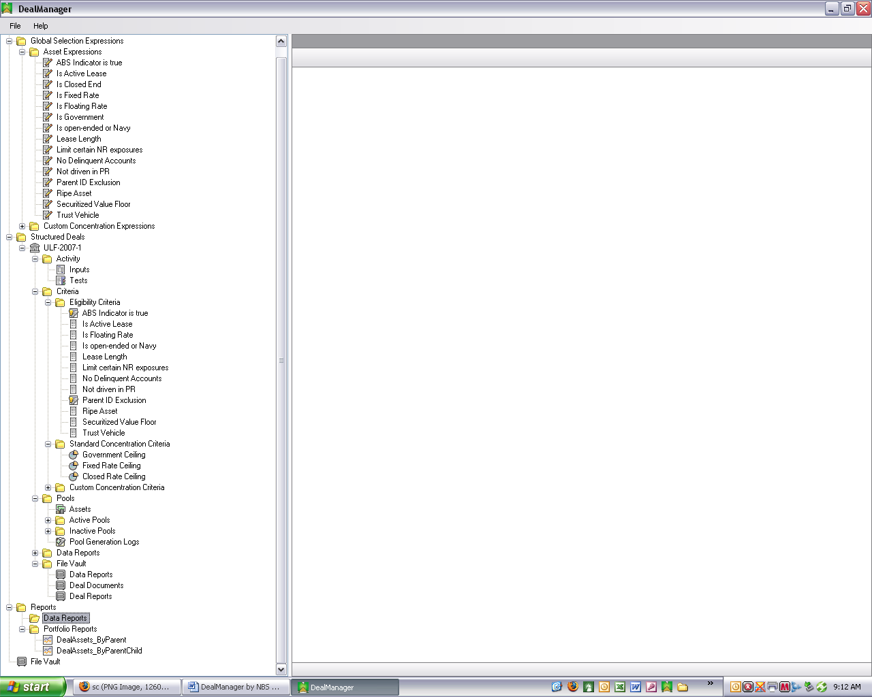
Global Expressions are custom calculations and true/false conditions defined by the user to reflect conditions required by the Securitization documents.

These calculations and conditions are used to define Eligibility and Concentration Criteria for each Securitization transaction.
The Deals section contains information about each specific Securitization transaction, including the criteria selected and/or defined by the user to create Securitization pools.
“Data Reports” are extracts configured by the user to export Asset data from the DM database into a pre-defined Excel workbook. Once in the workbook, the user can use the data in models and reports.
These standard reports were developed using Crystal Reports XI. The user can customize each report and/or add new reports.

Create Global Asset Expressions
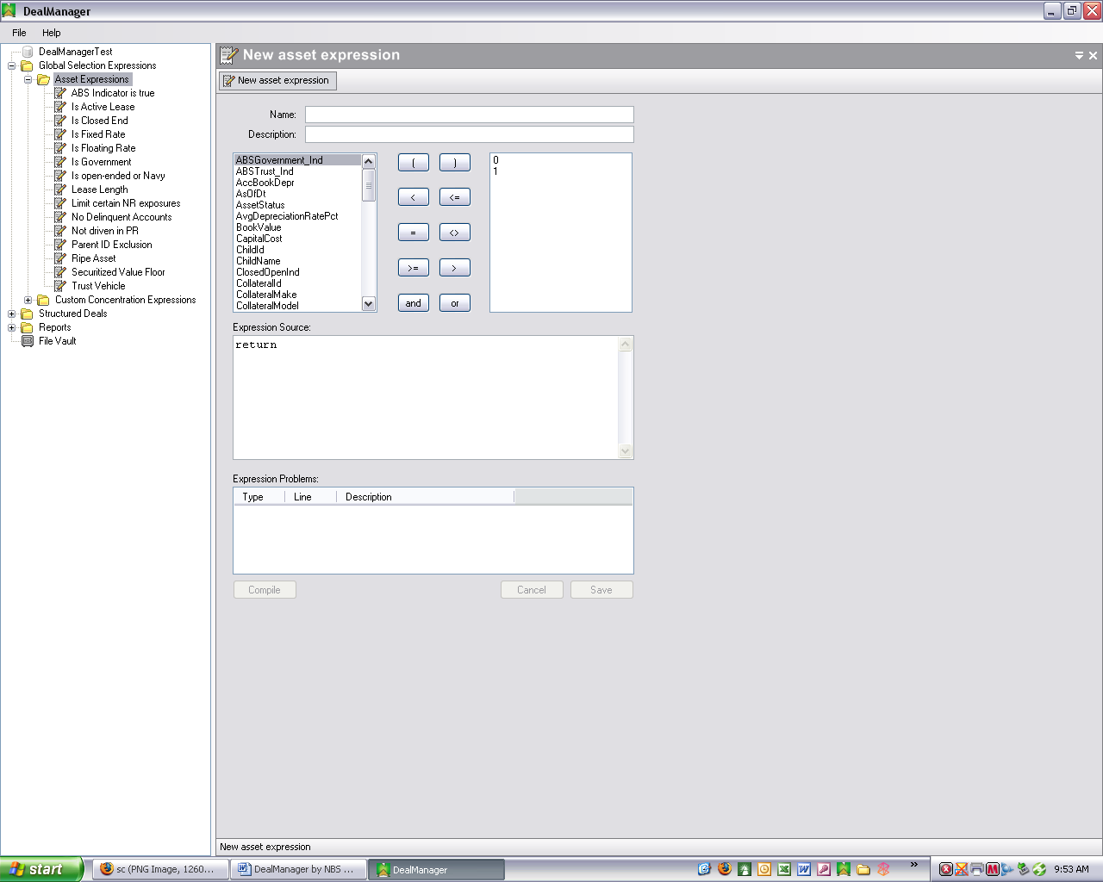
Click the “Compile” button when finished defining each Expression. This causes a test of the syntax to ensure that the Expression is properly defined.

Click the “Save” button to store the new Expression in the database.

DM comes with a number of standard Asset Expressions applicable to all deals. Users also have the ability to create additional Asset Expressions specific to their business.

To add data elements, the user modifies the Assets table in the DM database, and then re-runs the Configurator application (See “Configurator” above). After doing this, the user can create new Expressions based on these new data elements.

Creation of New Asset Expressions
To create a new Asset Expression:

- Asset Expressions: Right-click on the Asset Expressions group item in the left window pane, and select “New”. After doing this, the “New asset expression” form will open in the right window pane. For a full list of all standard Asset Expressions, see Appendix 3 – Standard Asset Expressions.

- Name: Enter a name for the new Expression in the “Name” blank.

- Description: Enter a description in the “Description” blank (optional).

- Field List: Select the desired field from the left-hand side list box. For a full list of all available database fields and descriptions of each, see Appendix 4 – Listed Database Fields.

- Operators: Select the desired operator (=, >, etc.) from the center area, or type the formula directly in the Expression Source box.

- Expression Source Box: Complete the Expression by typing in the proper numbers, words, codes, etc. in the Expression Source box. NOTE: The next version of DM will contain cascading parameters, which will adjust based on the field name selected from the Field List.

- Compile: Click the “Compile” button. This process checks the syntax of the Expression, ensuring that the item was properly defined. However, this step does not ensure that the Expression was defined to generate the desired result.

- Expression Problems Box: This box lists the problems encountered, if any, when the Expression’s syntax is checked during compiling. The description for each item identifies the type of problem, the Expression line on which it occurs and a description of the problem.

- Save: If, after clicking “Compile”, the Expression is shown to be syntactically correct (i.e., there are no problems listed in the Expression Problems box), click the “Save” button to save the Expression to the database. Once saved, the Expression can be used to generate Pools for any Structured Deal.

- Cancel: Click the “Cancel” button to cancel your last changes in the Expression Source box.

Editing and Deleting Existing Asset Expressions
To edit an existing Expression, right-click on the specific Asset Expression in the left window pane, and select “Edit” (or simply double-click on the specific Asset Expression). The remaining steps are the same as set forth above for creating a new Expression. To delete an existing Expression, right-click on the specific Asset Expression in the left window pane, and select “Delete”.

Create Global Custom Concentration Expressions
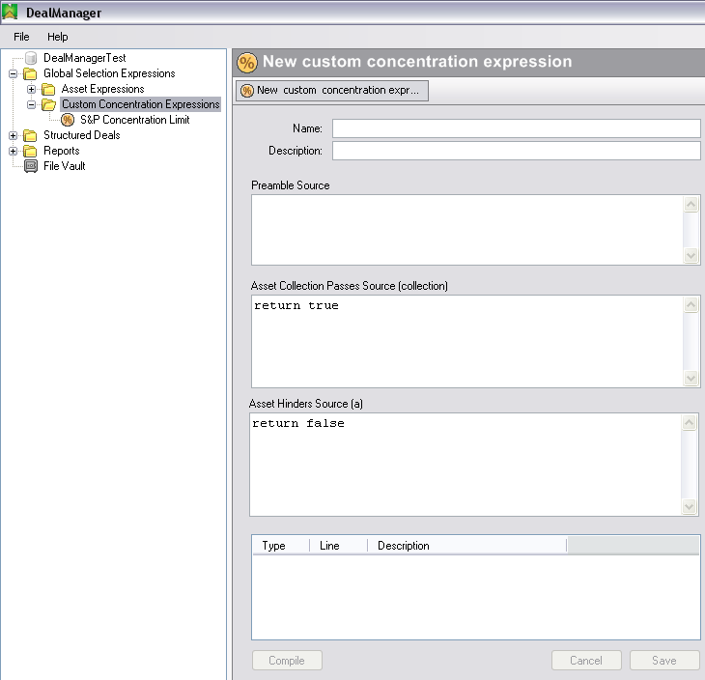

Creation of New Custom Concentration Expressions
Some Deals may require criteria that are too complex to implement through the DM interface, so the user or NBS creates the custom criteria, customized for the particular Deal. Once created, the user applies this criterion to the Deal as described below in “Deals-Configure Deal”.

To create a new Custom Concentration Expression:

- Custom Concentration Expressions: Right-click on the Custom Concentration Expressions group item in the left window pane, and select “New”. After doing this, the “New custom concentration expression” form will open in the right window pane. [For a full list of all standard Custom Concentration Expressions, see Appendix 5 – Standard Custom Concentration Expressions.]

- Name: Enter a name for the new Expression in the “Name” blank.

- Description: Enter a description in the “Description” blank (optional).

- Preamble Source Box: Select the Asset Expression to which the Concentration limiters will be applied. For instance, to create a limit of exposure to all Assets that have parents equal to “Coach”, the user would first create an Asset Expression called “Coach Parent” and then use this expression in the Concentration calculation.

- Select the Guarantee: This is the comparison of the actual value to the limit. Use >, >=, <, <=.

- Calculation Aggregation Type: Indicate whether the calculation should be based on the sum of Securitized value or based on the count of Assets in the Active Pools. NOTE: The concentration calculations are based on the entire set of Active Pools for a single Deal. So, if the user was to create a Concentration Criteria and the Deal already had six Active Pools, the Concentration Criteria would attempt to create a 7th Pool, such that the limitations defined within the Concentration Criteria comply across all Assets in all six Active Pools and the 7th Inactive Pool.

- Asset Collection Passes Source (collection) Box: [INSERT DESCRIPTION HERE]

- Asset Hinders Source (a) Box: [INSERT DESCRIPTION HERE]

- Compile: Click the “Compile” button. This process checks the syntax of the Expression, ensuring that the item was properly defined. However, this step does not ensure that the Expression was defined to generate the desired result.

- Expression Problems Box: This box lists the problems encountered, if any, when the Expression’s syntax is checked during compiling. The description for each item identifies the type of problem, the Expression line on which it occurs and a description of the problem.

- Save: If, after clicking “Compile”, the Expression is shown to be syntactically correct (i.e., there are no problems listed in the Expression Problems box), click the “Save” button to save the Expression to the database. Once saved, the Expression can be used to generate Pools for any Structured Deal.

- Cancel: Click the “Cancel” button to cancel your last changes in the Expression Source box.

Editing and Deleting Existing Custom Concentration Expressions
To edit an existing Expression, right-click on the specific Custom Concentration Expression in the left window pane, and select “Edit” (or simply double-click on the specific Custom Concentration Expression). The remaining steps are the same as set forth above for creating a new Expression. To delete an existing Expression, right-click on the specific Custom Concentration Expression in the left window pane, and select “Delete”.

Deals
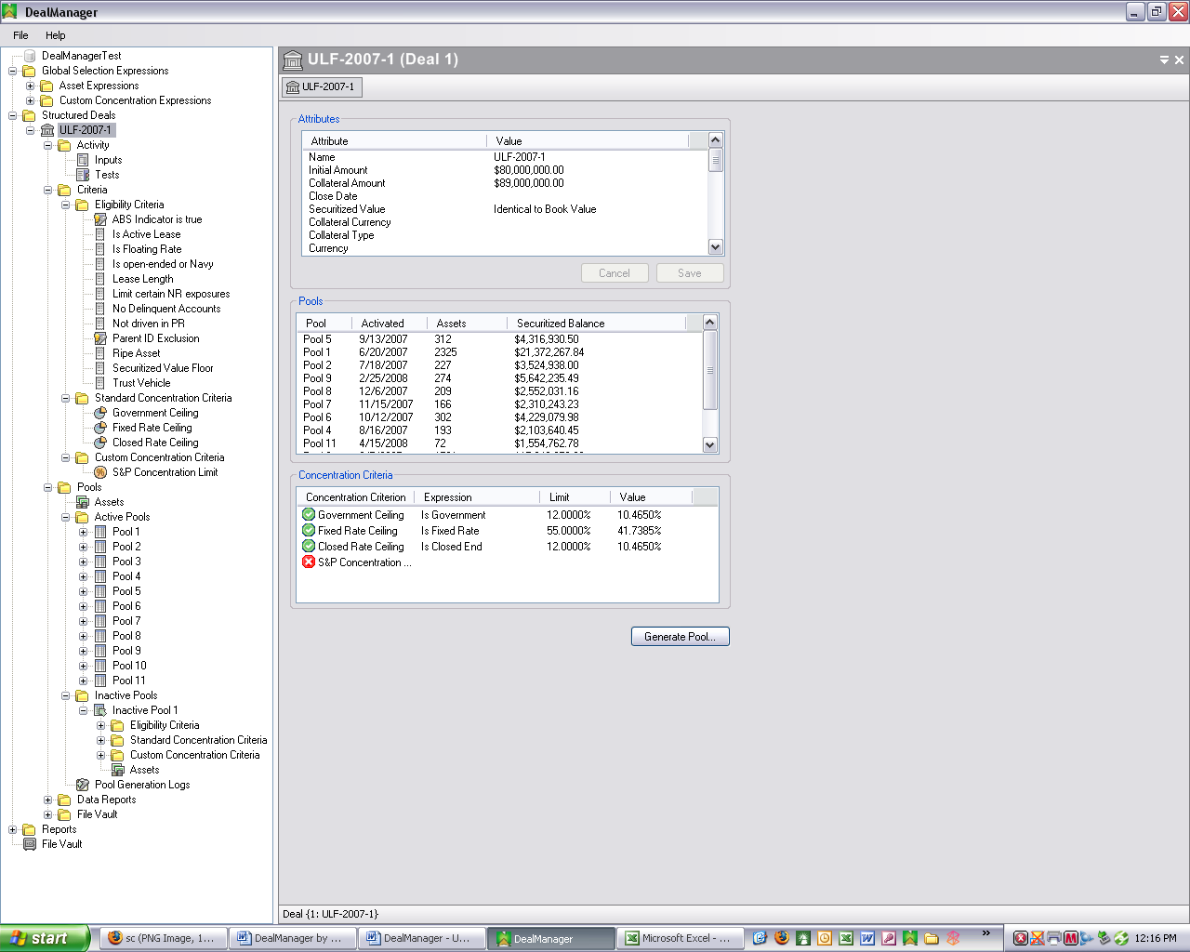

The Deal is the cornerstone of the DM application from which most of the DM activity flows. The Deal section of DM captures information about the specific Securitization transaction, including the data elements set forth in Appendix 6 – Data Elements. Most of this information is required to enable users to report on the primary elements of the transaction.

Create New Deal
To create a new Deal:

- Create New Deal: Right-click on the “Structured Deals” group item in the left window pane, and select “New”. After doing this, the “New Deal” form will open in the right window pane.

- Name: Enter a name for the new Deal in the “Name” blank.

- Initial Amount: Enter the Deal asset amount in the “Initial Amount” blank.

- Collateral Initial Amount: Enter the Deal collateral asset amount in the “Collateral Initial Amount” blank.

- Save: Click the “OK” button to save the new Deal data.

- Cancel: Click the “Cancel” button to cancel your entries.

Copy Existing Deal
To copy an existing Deal, right-click on a specific Deal and select “Copy” to open the “New Deal” form in the right window pane. After doing this, follow the same steps set forth above for “Create New Deal”.

View Deal Information
To view a Deal’s information, right-click on a specific Deal name in the left window pane, and select “View”. After doing this, the Deal information form will open in the right window pane. The Attributes box sets forth the basic information regarding the Deal. The Pools box lists the activation date, number of assets and securitized balance for each active pool in the Deal. The Concentration Criteria box lists the Expression, limit and value for each Concentration Criterion used to create the most recently activated Pool, as well as the actual result from that calculation.

Configure Deal
To configure a Deal:

Select Deal
Expand the “Structured Deals” folder in the left window pane, and then select and expand a Deal name.

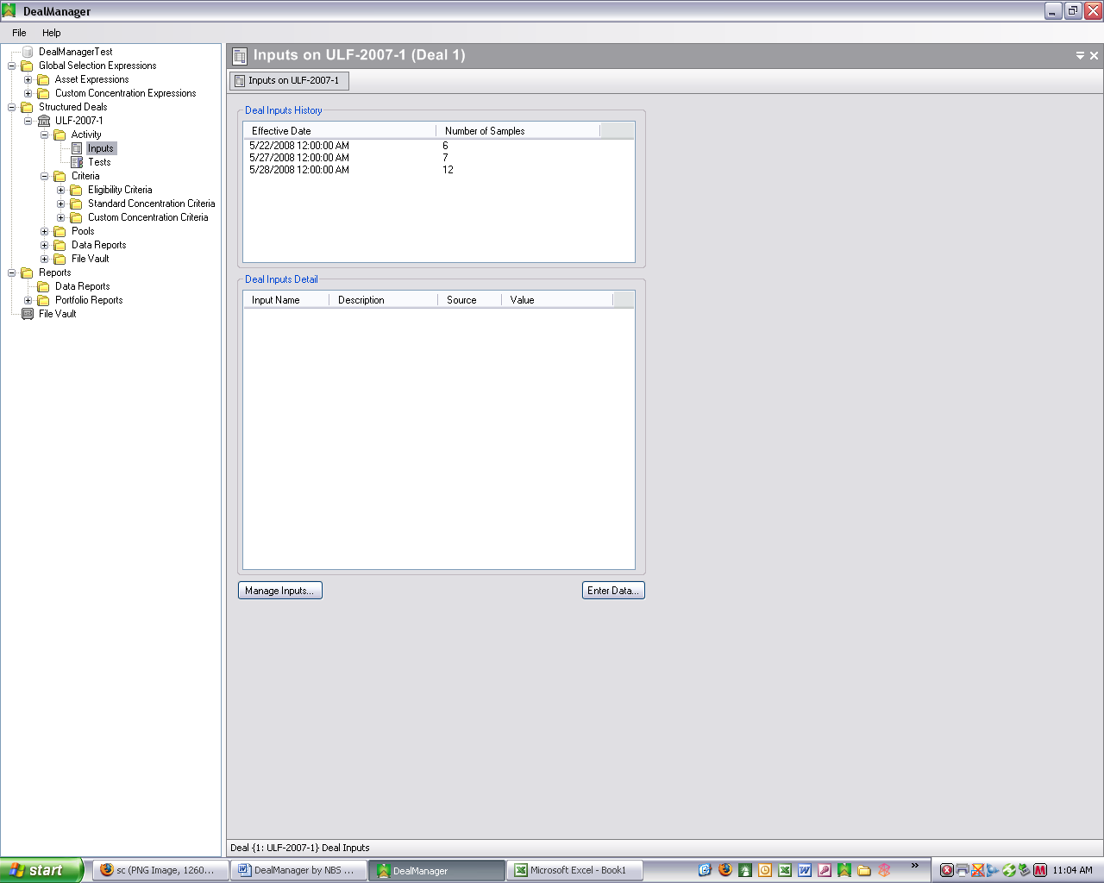

Define Deal Inputs
Deal Inputs are data points that the user requires in order to complete the SR (described below). The only way for these to be inserted into DM is for the user to enter them each period (month or week) as Deal Inputs.

To view Deal Inputs for the current period, expand the “Activity” folder for the Deal in the left window pane, right-click on “Inputs” and select “View” (or simply double-click on “Inputs”). After doing this, the “Inputs” form will open in the right window pane (see image above).
The Deal Inputs History box shows the Effective Date and Number of Samples for each set of Deal Inputs. This data history is required to accommodate the user’s need to modify Deal Inputs over the duration of the Deal.

Creation and maintenance of the Deal Inputs are accomplished via the Deal Inputs Detail box. This box lists each Deal Input’s Name, Description, Source and Value for the Deal Inputs set selected in the Deal Inputs History box.

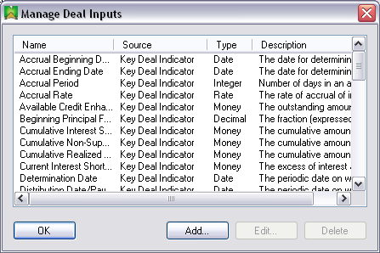

To manage the Deal Inputs, click on the “Manage Inputs” button at the bottom of the “Inputs” form which will open the “Manage Deal Inputs” form (see image above). This form lists each Deal Input’s Name, Source, Type and Description for the currently selected Deal Inputs set.
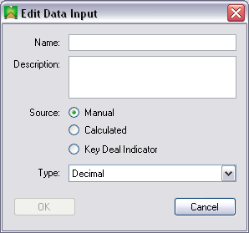
To add a new Deal Input to the list:

- Add Deal Input: Click the “Add” button, which will open the “Edit Data Input” form (see image above).
- Name: Enter a name for the new Deal Input in the “Name” blank.

- Description: Enter a description for the Deal Input in the “Description” blank (optional).

- Source: Select one of the three Deal Input Source options (Manual, Calculated or Key Deal Indicator).

- Type: Select the type of data item from the drop-down list (Integer, Boolean, Decimal, Date, String, Money or Rate).

- Save: Click the “OK” button to save the new Deal Input.

- Cancel: Click the “Cancel” button to cancel your entries.

To edit an existing Deal Input, click the “Edit” button on the “Manage Deal Inputs” form and follow the instructions set forth above for adding a new Deal Input. Click the “Delete” button on the “Manage Deal Inputs” form to delete an existing Deal Input.

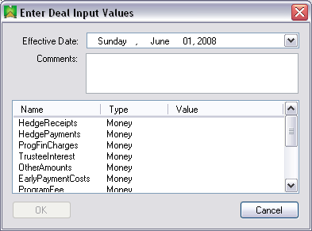

To enter values for the Deal Inputs, click on the “Enter Data” button at the bottom of the “Inputs” form which will open the “Enter Deal Input Values” form (see image above). This form lists each Deal Input’s Name, Type and Value for the currently selected Deal Inputs set. To enter values:

- Effective Date: Select a date with the calendar accessed with the drop-down button.

- Comments: Enter any comments in the “Comments” blank (required).

- Values: Click in the area beneath the Value column opposite each Deal Input and type a value.

- Save: Click the “OK” button to save the entered Deal Input Values. This button only becomes enabled after a comment is entered in the Comments blank.

- Cancel: Click the “Cancel” button to cancel your entries.
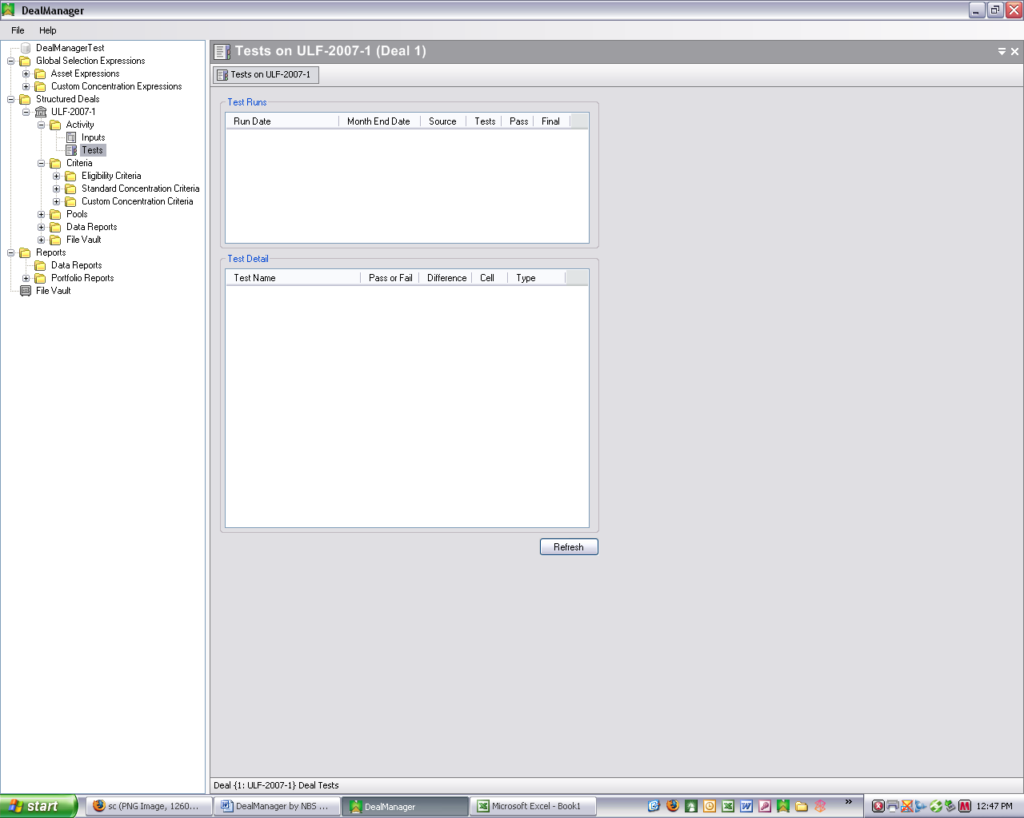

Define Deal Tests
Deal Tests are values in the SR that the user captures and loads into the DM database each time an SR is run (see “Servicer Report” below).

To view Deal Tests for the current period, expand the “Activity” folder for the Deal in the left window pane, right-click on “Tests” and select “View” (or simply double-click on “Tests”). After doing this, the “Tests” form will open in the right window pane (see image above).
The Test Runs box shows the Run Date, Month End Date, Source, Tests, Pass/Fail status of the Test and Final status of the Test. [NEED FULL DESCRIPTION HERE]

The Test Detail box lists for each Deal test its Name, Pass/Fail status, Difference, Cell and Type. Click the Refresh Button to refresh the results reflected in the Tests form. [NEED FULL DESCRIPTION HERE]
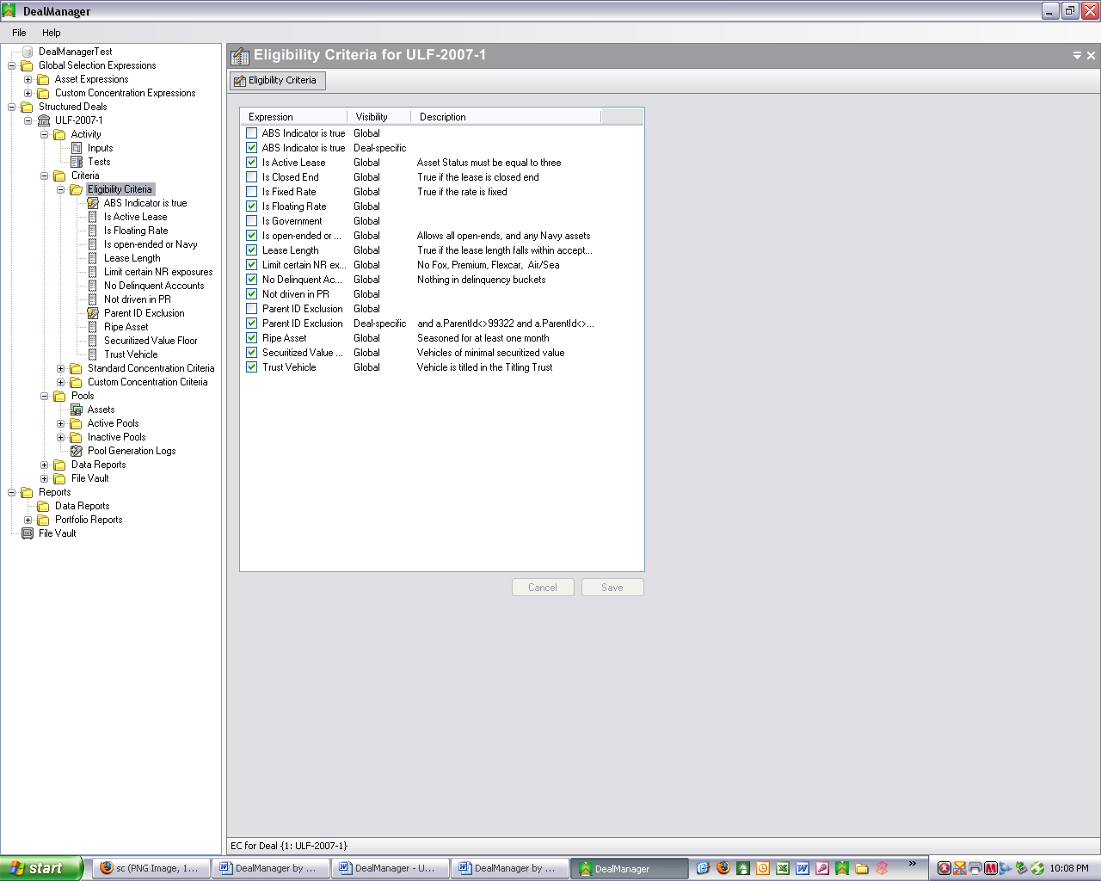

Define Eligibility Criteria
To define the Eligibility Criteria for the current period, expand the “Criteria” folder in the left window pane, right-click on “Eligibility Criteria” under the desired Deal and click on “Select”. After doing this, the “Eligibility Criteria” form will open in the right window pane (see image above). Click on the checkboxes for the desired criteria from the list. When done making your selections, click the “Save” button (or the “Cancel” button to cancel your selections).

If the user modifies any of the Global Asset Expressions to fit a particular Deal, DM automatically creates a new Deal Expression. This Global/Deal-specific status is reflected in the “Visibility” column in the “Custom Concentration Criteria” form.

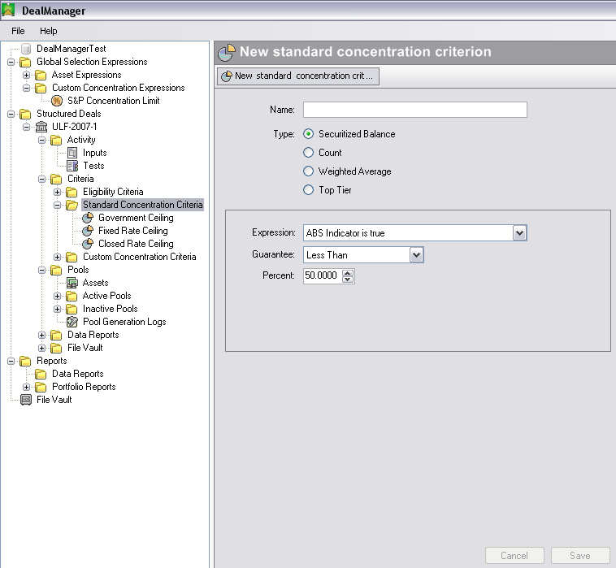

Define Standard Concentration Criteria
The Concentration criteria are used to manage the Pool’s exposure to certain attributes of its various Assets. The Securitization documents will, in most cases, outline the parameters and limits that define the maximum exposure to these Assets permitted for the Pool. In order to create a Concentration Criteria for a particular Deal, the user must first create a Global Asset Expression that captures the requirements of the Criterion (see “Create Global Asset Expressions” above).
The Concentration calculations are based on all Active Pools for a specific Deal. If the user creates a new Concentration Criterion for a Deal with six Active Pools, the new Concentration Criterion causes the creation of a seventh Pool. The limitations defined within the new Concentration Criterion must comply across all Assets in the six Active Pools as well as the new Inactive Pool.

To define the Standard Concentration Criteria for the current period, right-click on “Standard Concentration Criteria” and select “New”. After doing this, the “New standard concentration criteria” form will open in the right window pane (see image above). Complete the following data items:

- Name: Enter a name for the new “Standard Concentration Criteria” in the “Name” blank.

- Type: Select one of the four listed options (Securitized Balance, Count, Weighted Average or Top Tier).

- Expression: Select one of the Global Asset Expressions from this drop-down list to which the Concentration limit will be applied. For instance, to create a limit of exposure to all Assets that have parents equal to “Coach”, the user would first create a Asset Expression called “Coach Parent” and then use this expression in the Concentration calculation.

- Guarantee: Select one of the four options in the drop-down list (Less Than, Less Than or Equal To, Greater Than or Equal To or Greater Than). This is the comparison of the actual value to the limit.

- Percent: Set the percentage limit for the new Criterion.

- Save: Click the “Save” button to save the new Criterion.

- Cancel: Click the “Cancel” button to cancel your answers.

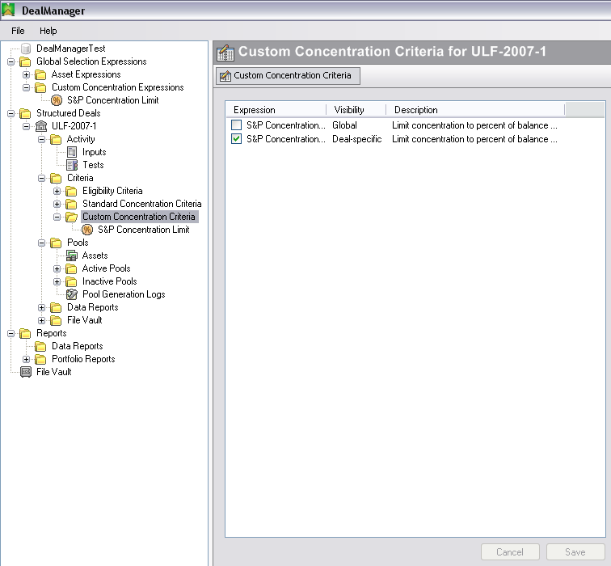

Apply Custom Concentration Criteria
To apply Custom Concentration Criteria to a Deal, right-click on “Custom Concentration Criteria” and click on “Select”. After doing this, the “Custom Concentration Criteria” form will open in the right window pane (see image above). Click on the list’s checkboxes to select the desired Expressions to apply when creating a new Pool (described below) for the selected Deal.

When done making your selections, click the “Save” button (or the “Cancel” button to cancel your selections).

Pools
When first created, a Pool is Inactive to ensure compliance with all defined criteria before being officially made part of the Deal. The user can create any number of Inactive Pools, and a single Asset can be in multiple Inactive Pools. However, once the user selects one Pool to “sell” into the Securitization Deal for the particular time period, then all remaining Inactive Pools are removed and the selected Pool becomes an Active Pool. Any Assets that are not in any Active Pools are referred to as Free Assets.

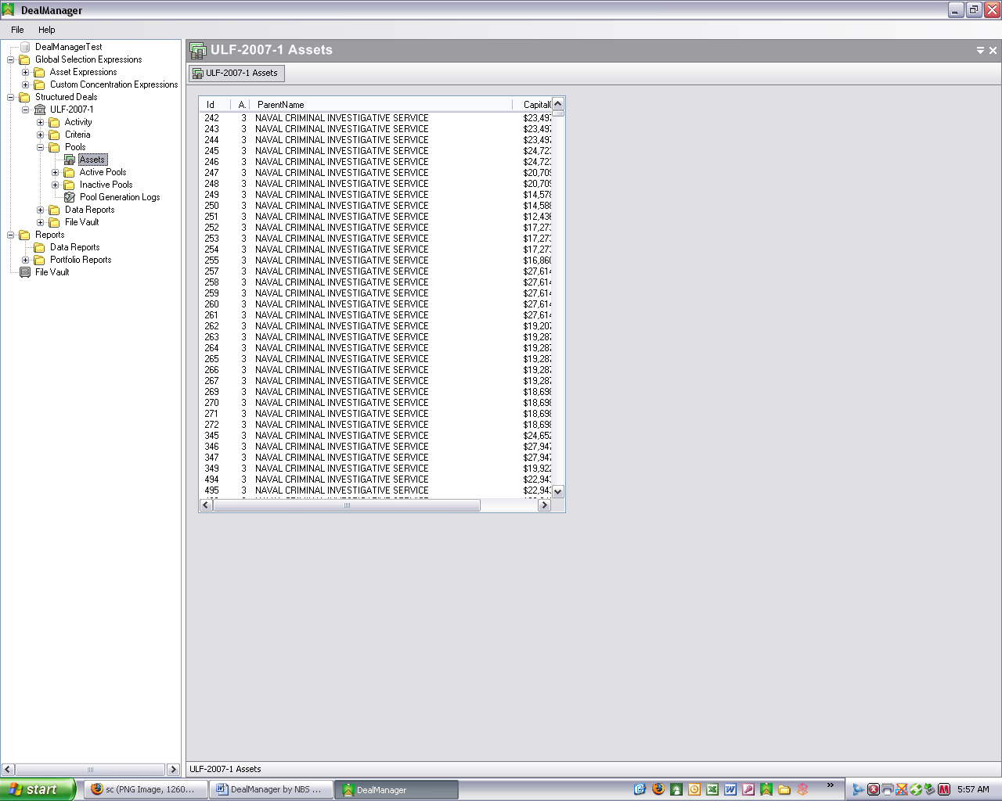

Assets
To view all Assets for a particular Deal for the current period, expand the “Pools” item for the Deal in the left window pane, right-click on “Assets” and select “View” (or simply double-click on “Assets”). After doing this, the “Assets” form will open in the right window pane (see image above).

The Assets form displays for each Deal Asset the Id, AssetStatus, ParentName, CapitalCost and SecuritizedValue. [NEED FULL DESCRIPTION HERE]

Create Pool
Once all types of Criteria have been configured for the Deal, the user can create one or more Securitization “Pools”, which are collections of Assets that meet all the defined criteria.

For a given period, the user can create any number of Pools, but can only select one “Active” Pool for that period. In other words, the user can modify and revise criteria and generate many inactive Pools, tweaking the criteria to see the impact on the resulting Pool. However, only one Pool can be activated per Deal per cut-off date. All Active Pools for a given Deal are listed in the Deals form, as shown above under “Deals”.

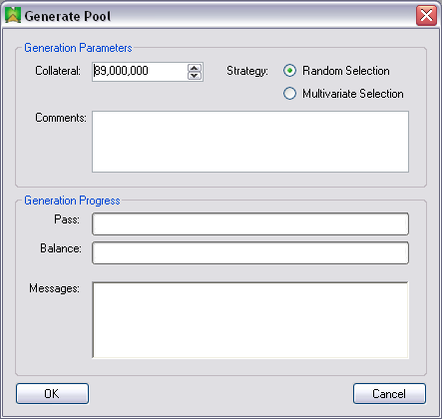

To generate a new Pool:

- Generate Pool: Right-click on a specific Deal name in the left window pane, and select “Generate Pool”. After doing this, the Generate Pool form will open in the right window pane (see image above).

- Collateral: Enter the amount of collateral for the Pool.

- Strategy: Select the type of asset selection strategy (Random Selection or Multivariate Selection) to employ in creating the Pool.

- Comments: [INSERT DESCRIPTION HERE]

- Generation Progress: [INSERT DESCRIPTION HERE]

- Collateral Initial Amount: Enter the Deal collateral asset amount in the “Collateral Initial Amount” blank.

- Save: Click the “OK” button to generate the new Pool using the entered selections.

- Cancel: Click the “Cancel” button to cancel Pool generation.

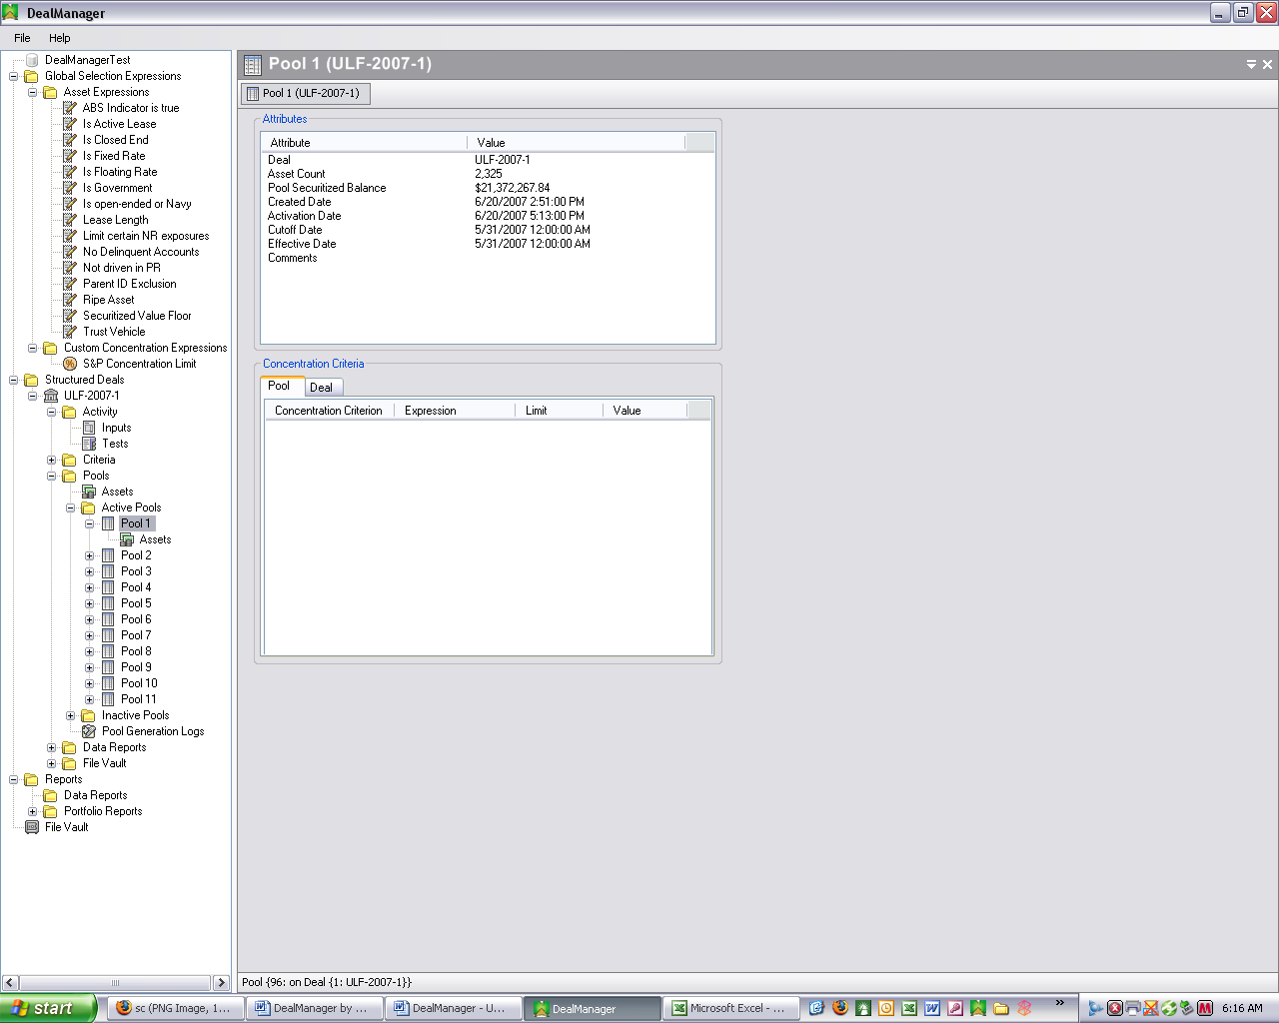

Active Pools

View
To view a particular Active Pool’s information for the current period, expand the “Active Pools” folder for the Deal in the left window pane, right-click on a specific Active Pool name, and select “View”. After doing this, the Pool information form will open in the right window pane (see image above).

Similar to what is shown for a Deal, the Attributes box sets forth the basic information regarding the Pool. The Concentration Criteria box lists, both on a Pool and a Deal basis, the Concentration Criterion, Expression, Limit and Value for each Concentration Criterion used to create the Pool. [NEED FULL DESCRIPTION HERE]

Assets
To view all Assets for a particular Active Pool for the current period, expand the particular Pool item in the left window pane, right-click on “Assets” and select “View” (or simply double-click on “Assets”). After doing this, the “Assets” form for the Pool will open in the right window pane, and will look similar to the Assets form described above for all Assets for the entire Deal.

Inactive Pools

View
To view a particular Inactive Pool’s information for the current period, expand the “Inactive Pools” folder for the Deal in the left window pane, right-click on a specific Inactive Pool name, and select “View”. After doing this, the Pool information form will open in the right window pane and show the same information described above for an Active Pool. However, the Inactive Pool form will also include buttons to “Rebalance” and “Activate” the Pool.

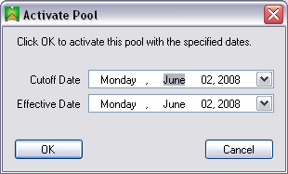

Activate
To activate a particular Inactive Pool for the current period, expand the “Inactive Pools” folder for the Deal in the left window pane, right-click on a specific Inactive Pool name, and select “Activate” (or click the “Activate” button on the Pool information form described above under “View”). After doing this, the “Activate Pool” form will appear in the right window pane with blanks for the user to insert the Pool’s Cutoff and Effective dates for the underlying Assets in the Deal’s Assets table (see image above). Click the “OK” button to activate the pool with the specified dates (or click “Cancel” to close the form without activating the pool).

Rebalance
To rebalance a particular Inactive Pool for the current period, expand the “Inactive Pools” folder for the Deal in the left window pane, right-click on a specific Inactive Pool name, and select “Rebalance” (or click the “Rebalance” button on the Pool information form described above under “View”). After doing this, the “Rebalance Pool” form will appear in the right window pane. The “Rebalance Pool” form is identical to the “Generate Pool” form shown above under “Create Pool”.

Delete
To delete a particular Inactive Pool for the current period, expand the “Inactive Pools” folder for the Deal in the left window pane, right-click on a specific Inactive Pool name, and select “Delete”.

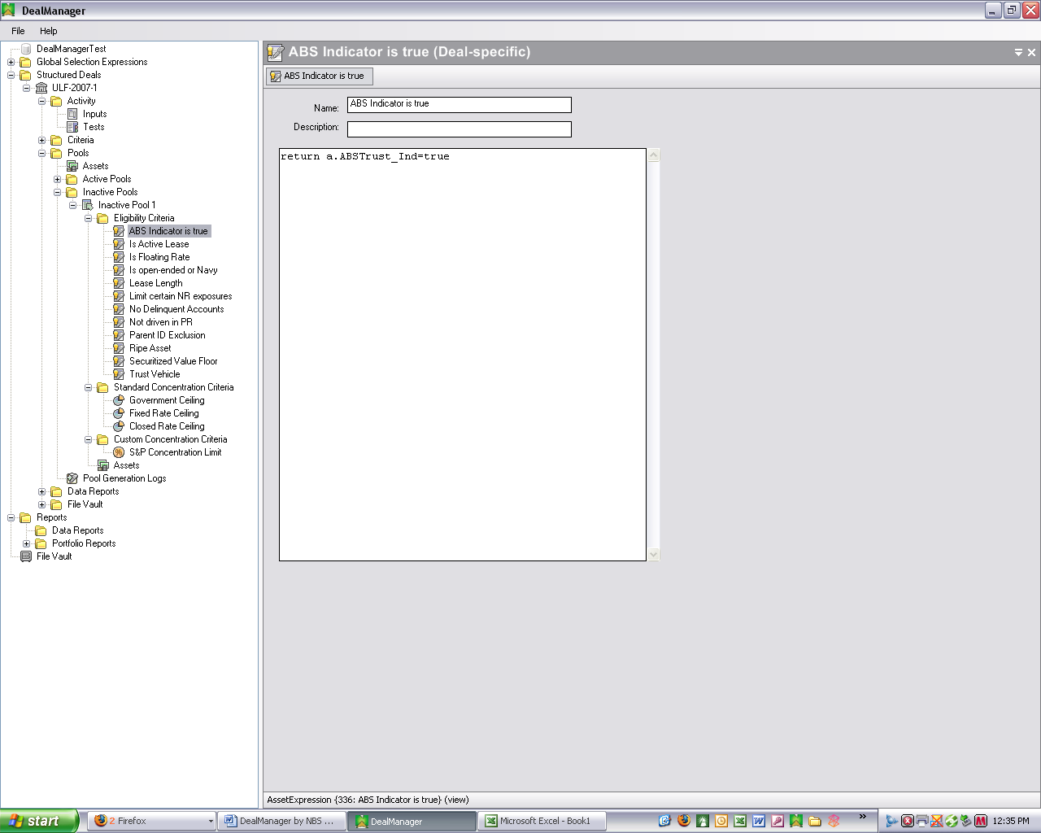

Eligibility Criteria
To view the Eligibility Criteria for an Inactive Pool for the current period, expand the particular Pool item in the left window pane, expand the “Eligibility Criteria” folder, right-click on a specific Eligibility Criterion and select “View” (or simply double-click on the specific Criterion). After doing this, the “Eligibility Criteria” form will open in the right window pane (see image above). This form will display the code for the Expression.
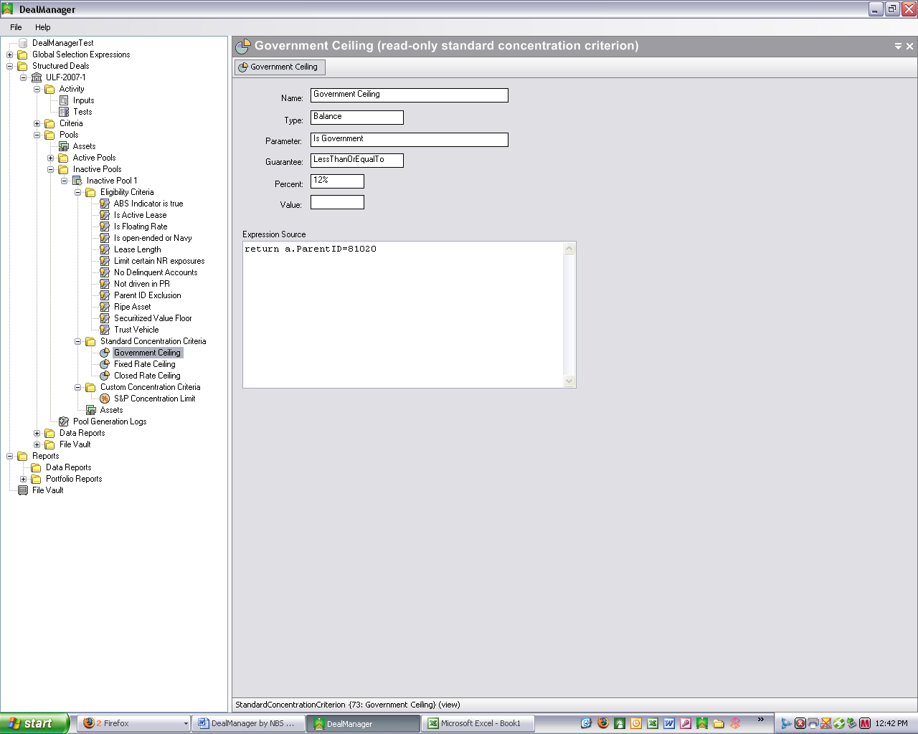

Standard Concentration Criteria
To view the Standard Concentration Criteria for an Inactive Pool for the current period, expand the particular Pool item in the left window pane, expand the “Standard Concentration Criteria” folder, right-click on a specific Standard Concentration Criterion and select “View” (or simply double-click on the specific Criterion). After doing this, the “Standard Concentration Criteria” form will open in the right window pane (see image above). This form will display the settings and code for the Expression.
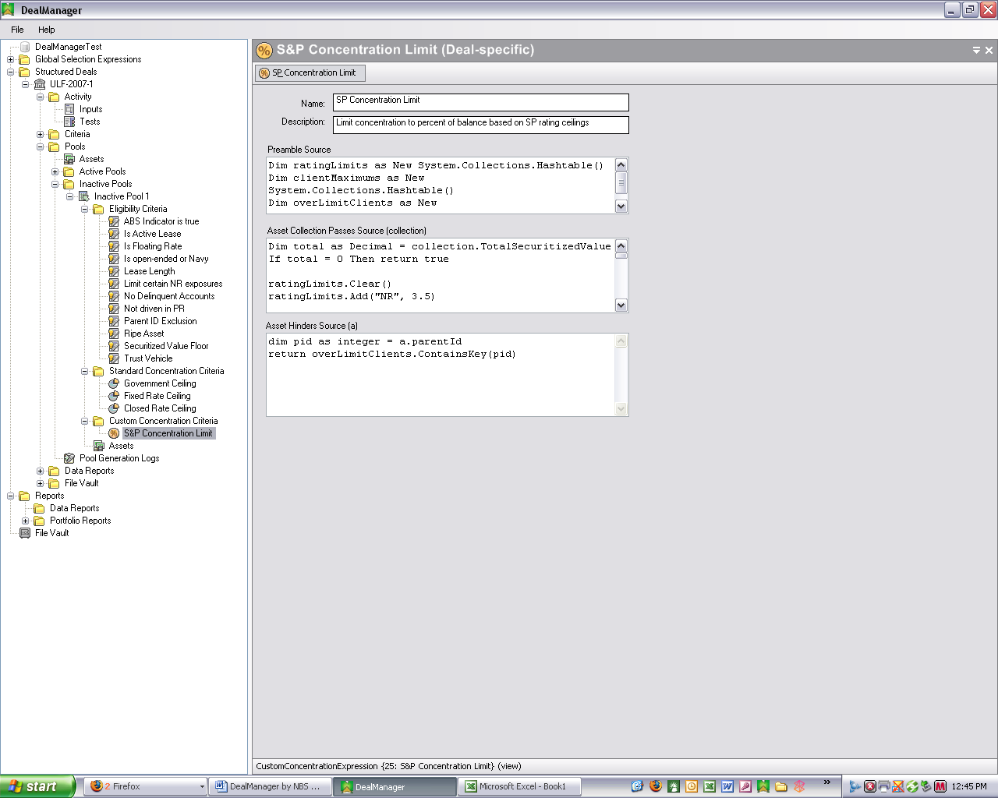

Custom Concentration Criteria
To view the Custom Concentration Criteria for an Inactive Pool for the current period, expand the particular Pool item in the left window pane, expand the “Custom Concentration Criteria” folder, right-click on a specific Custom Concentration Criterion and select “View” (or simply double-click on the specific Criterion). After doing this, the “Custom Concentration Criteria” form will open in the right window pane (see image above). This form will display the settings and code for the Expression.

Assets
To view all Assets for a particular Inactive Pool for the current period, expand the particular Pool item in the left window pane, right-click on “Assets” and select “View” (or simply double-click on “Assets”). After doing this, the “Assets” form for the Pool will open in the right window pane, and will look similar to the Assets form described above for all Assets for the entire Deal.

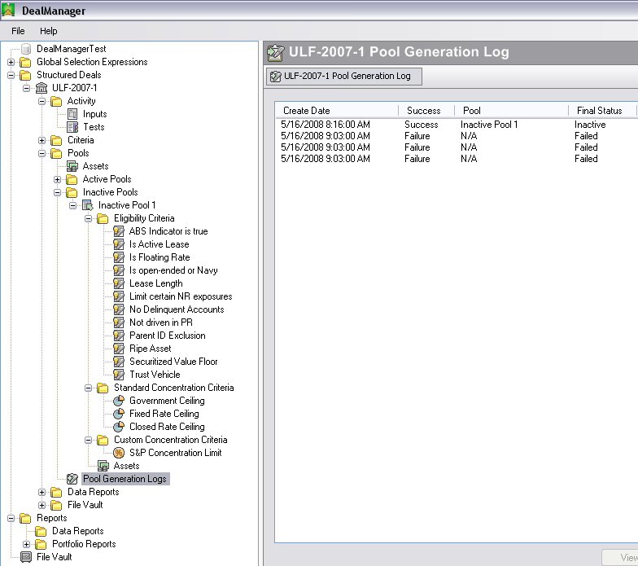

Pool Generation Logs
To view the Pool Generation Logs for a Deal for the current period, expand the Pools folder in the left window pane, right-click on “Pool Generation Logs” and select “View” (or simply double-click on “Pool Generation Logs”). After doing this, the “Pool Generation Log” form will open in the right window pane (see image above). This form will display the Creation Date, Success/Failure status, Pool name, and Final Status for each Pool generation attempt.

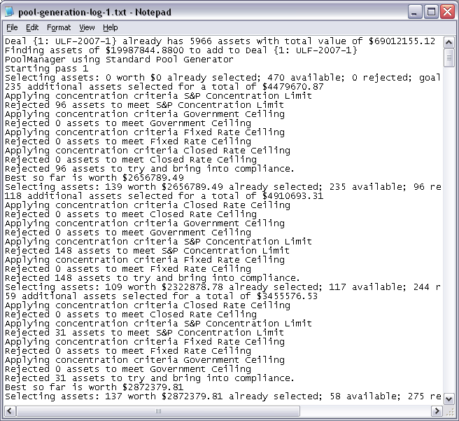

To view the Pool Generation Log details for a specific Pool Generation attempt, select a specific Pool from the form’s list and click the “View” button at the bottom right-hand corner of the Pool Generation Log form (see image above). This form will display the .txt Notepad file detailing the Pool Generation history for the selected Pool.

Deal Reports

Deal Data Reports
The DM application returns a history of all data elements required for Securitization reporting and analysis. Most of this reporting is handled by MS Excel, with DM providing an interface through which the user can define the type of Asset data to be exported into an Excel workbook file. This feature ensures reporting accuracy by controlling the entire export process. It also permits the user to adjust and modify Excel reports, as required by the business, without having to redevelop hard-coded reports.
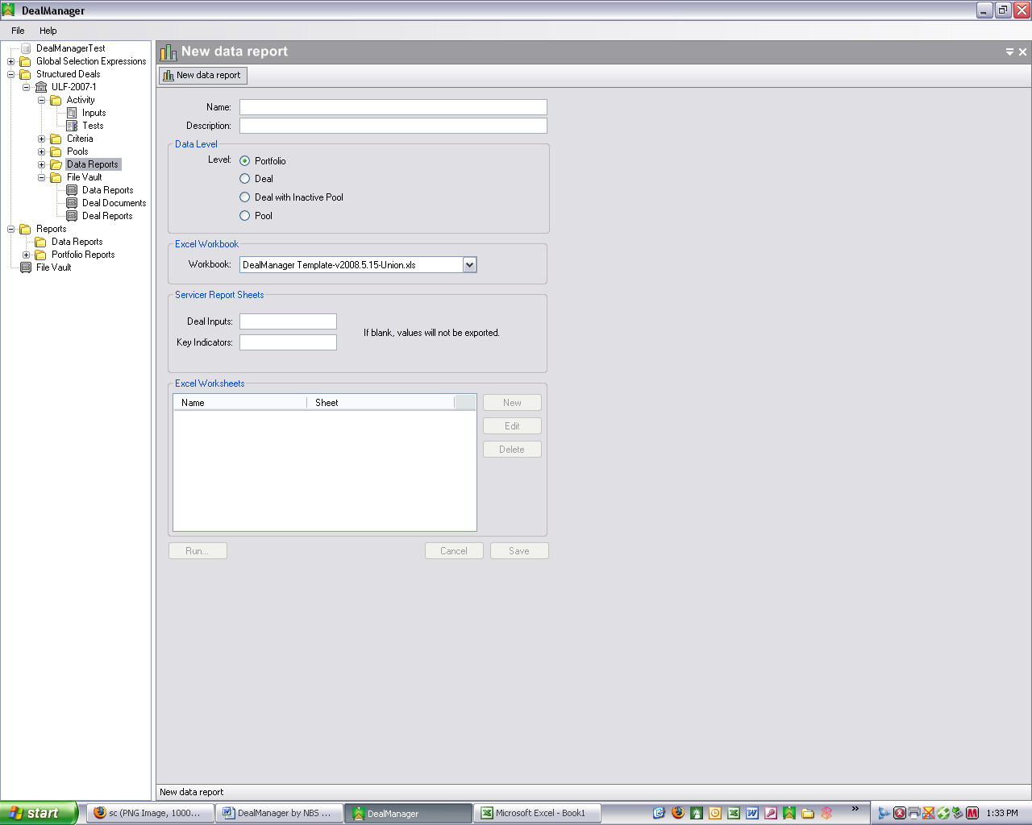

Create New Data Report
To create a new Data Report:

- Data Reports: Right-click on the Data Reports folder in the left window pane, and select “New”. After doing this, the “New data report” form will open in the right window pane (see image above).
This Data Report creation process assumes that an MS Excel workbook is already created with the worksheets defined as described in paragraphs 6 and belowbelow. The named ranges discussed in paragraph are used to facilitate calculations and formulas contained within the Workbook. This permits changes in the actual size of the data without adversely impacting the formulas referencing such data. The formulas dynamically adjust to accommodate any changes in the size of the data set.

- Name: Enter a name for the new Data Report in the “Name” blank (e.g., Servicer Report ABC Funding Corp 20XX-1).

- Description: Enter a description in the “Description” blank (optional) (e.g., Servicer Report for the 20XX-1 Transaction).

- Data Level: Select whether DM should extract data from one Deal Portfolio, the entire Deal (i.e., all Pools), the entire Deal plus one Inactive Pool or for just one Pool.

- Excel Workbook File: Select, from the drop-down list, the name of the existing Excel file you want to use to create the new Data Report. This list is a collection of the files loaded in the Deal File Vault (described below).

- Required Excel Servicer Report Sheets: “Deal Inputs” and “Key Indicators” are two sheets required to be included in the Excel Data Report. These sheets should, in most cases, be named “Inputs” and “KDI-CI”, respectively. If either one is left blank, no Report will be generated.

- Save: After inserting names for the two sheets above, click “Save” to save these settings, and enable the other sheet buttons described below.

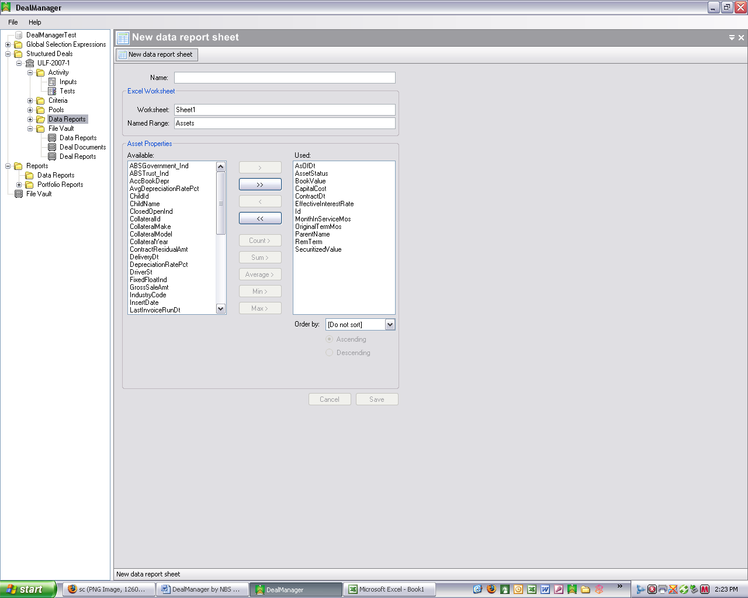

- Optional Excel Servicer Report Sheets: After saving the standard sheets described above, create any additional sheets required for the Deal by clicking the “New” button just right of the “Excel Worksheets” box. After doing this, the “New data report sheet” form will open in the right window pane (see image above).

  - Report Name: Enter a name for the new Data Report sheet in the “Name” blank.
  - Excel Worksheet Name: Enter a name for the Excel sheet that will contain the Report’s data in the “Worksheet” blank.
  - Excel Worksheet Named Range: Enter a name for the Excel Named Range that will contain the Report’s Asset data in the “Named Range” blank.
  - Select Asset Properties: If there are any Asset Properties listed in the Used box on the right side of the form, first remove them all by clicking the >> button in the center section. After doing this, select the applicable Asset Properties from the “Available” box by using either the >, >> or aggregation keys (Count, Sum, Average, Min or Max). The Aggregation options are aggregating commands that utilize the grouping feature of SQL when extracting data from the database.
  - Asset Order: Use the drop-down list of “Order by” to select which Asset Property to sort the data by (or choose Do not sort). If sorting, also select whether to sort in Ascending or Descending order.
  - Save: Click the “Save” button to save your worksheet settings.
  - Cancel: Click the “Cancel” button to cancel your worksheet settings changes.

- Edit Existing Optional Excel Servicer Report Sheet: To edit an existing optional sheet, select a sheet in the Excel Worksheets box and click the “Edit” button to open up the selected data report sheet. The remaining steps are the same as set forth above for creating a new data report sheet.

- Delete Existing Optional Excel Servicer Report Sheets: To delete an existing optional sheet, select a sheet in the Excel Worksheets box and click the “Delete” button.

- Save: After creating new or editing existing data report sheets, click “Save” to save these worksheet settings.

- Cancel: Click the “Cancel” button to cancel your worksheet settings changes.

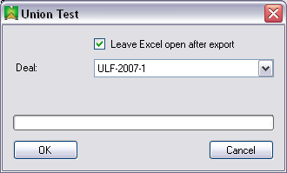

- Generate Data Report In Excel: To generate a configured Data Report in Excel, click the “Run” button in the lower left-hand portion of the form. After doing this, the above form will open in the right window pane. In most cases, you’ll want to check the box for “Leave Excel open after export” so that you can work with the Data Report in Excel after it is generated. The default Deal name selected will be the Deal under which you selected the Data Report to generate. When done making or confirming your selections, click “OK” to commence generation of the Data Report. Click “Cancel” to close the form without generating the Data Report.

Edit or Delete Existing Deal Data Report
To edit an existing Data Report, expand the Data Reports folder under the specific Deal in the left window pane, right-click on an existing data Report and select “Edit”. After doing this, the data report form (identical to that described above for Create New Data Report) will open in the right window pane. The remaining steps are the same as set forth above for creating a new Data Report. To delete an existing Data Report, right-click on the specific existing data Report in the left window pane, and select “Delete”.

Generate Deal Data Report
To generate a configured Data Report in Excel, expand the Data Reports folder under the specific Deal in the left window pane, right-click on an existing data Report and select “Run”. You can also accomplish this by opening a Data Report with either of the “New” or “Edit” options described above, and then clicking the “Run” button in the lower left-hand portion of the form. Then follow the instructions set forth above in the description for “Generate Data Report In Excel” under Create New Data Report.

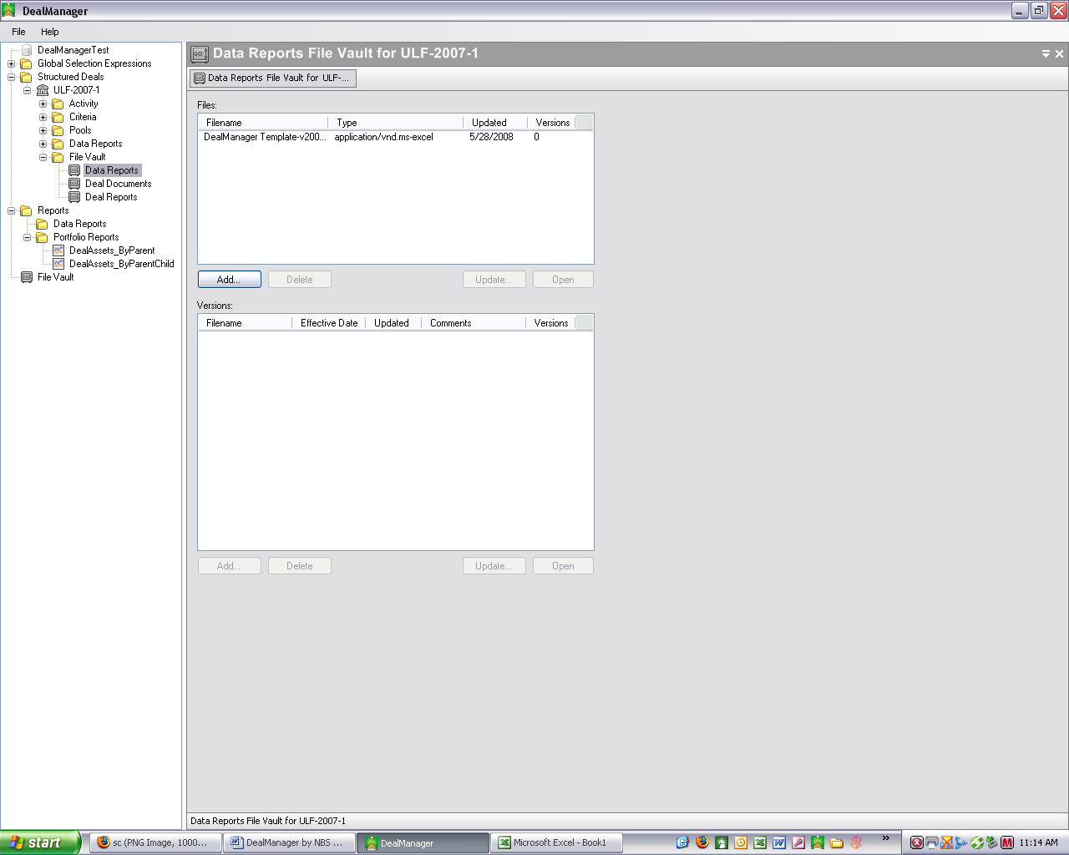

Deal File Vault
The Deal File Vault is the DM facility used to store all documents (Data Reports, Deal Documents and Deal Reports) required for the Deal.

View Deal Report Files
To view any documents stored in any of the Data Reports, Deal Documents or Deal Reports storage areas, expand the “File Vault” folder for the Deal in the left window pane, right-click on one of the three aforementioned Report items and select “View” (or simply double-click on one of the Report items). After doing this, the “File Vault” form will open in the right window pane (see image above).

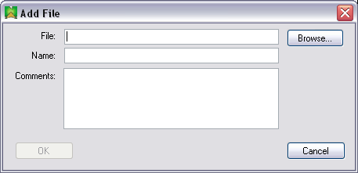

Add Deal Report File
To add a file to the Deal File Vault, click on the “Add” button just beneath the “Files” box in the ”File Vault” form described above. After doing this, the “Add File” form will open in the right window pane (see image above). The easiest way in which to add a file is to click the “Browse” button, navigate to the folder of the file to be added and then select the file from the folder’s listed files. You can also add a file by manually typing in the file’s full path name in the “File” blank and its file name in the “Name” blank (this is the name used to identify the file in the File Vault’s “Files” list). Click “OK” to complete the “Add” process, and “Cancel” to close the form without adding a file.

Open Deal Report File
To open a file in the Deal File Vault, select a filename in the “Files” list of the File Vault’s form and click on the “Open” button just beneath the “Files” box. After doing this, the selected file will open in Excel.

Update Deal Report File
To update a file already stored in the Deal File Vault, select a filename in the “Files” list of the File Vault’s form and click on the “Update” button just beneath the “Files” box. After doing this, the “Update File” form (nearly identical to the “Add File” form shown above) will open in the right window pane. Again, the easiest way in which to update a file is to click the “Browse” button, navigate to the folder of the replacement file and then select the replacement file from the folder’s listed files. You can also select the replacement file by manually typing in the file’s full path name in the “File” blank. Click “OK” to complete the file update process, and “Cancel” to close the form without updating the file.

Delete Deal Report File
To delete a file in the Deal File Vault, select a filename in the “Files” list of the File Vault’s form and click on the “Delete” button just beneath the “Files” box.

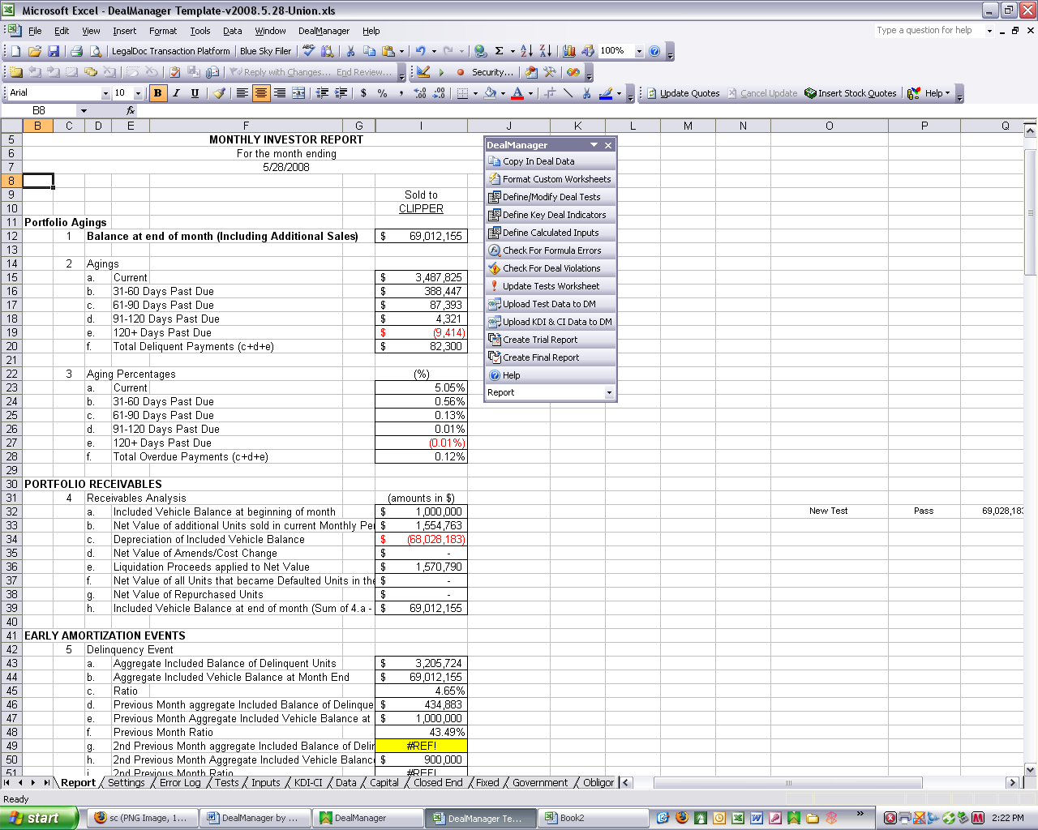

Servicer Report

SR Overview
The SR (see image above) serves as the primary vehicle for capturing and recording all types of data required for the Deal. While each SR will have characteristics and components unique to the particular Deal, all SRs contain a number of common elements and categories.

SR Common Elements and Categories

Exported Data
Data is exported from the DM database (DMDB) to the SR each time the SR is created. This data includes:

- Portfolio Data: User-defined columns from the Assets table.

- Inputs:

  - Manual Inputs: Data that is entered by the user each month through the DM interface; and

  - Calculated Inputs: Information that is calculated within prior SRs, loaded into the DMDB as part of the prior month process, stored in the DMDB and then exported to the SR for subsequent calculations. An example of a “Calculated Input” is a formula in the SR called “Over-collateralization Amount”. The SR may also need to calculate the 3-month average Amount, so the user will configure this value as a Calculated Input. Therefore, each monthly process will include the prior month’s values so the historic values can be used in the calculation process.

- Key Deal Indicators: This list includes a generic list of Deal-related calculations, most of which should apply to all Deals. The user will also map the respective fields to the SR at implementation time and the values will be loaded into the DMDB each month thereafter.

- Data Sheets: Defined by the user within DM as described in Create New Data Report above. These sheets will extract specific sets of data required by the Deal. For instance, the SR may require a list of the top 5 obligors and a sum of the Securitized Value for each. The user would then create a Data Sheet that sums Securitized Value and groups by obligor (i.e., Parent Name).

Data Consolidation and Data Formulas
The SR consolidates the required information from the various worksheets into a single “Staging” worksheet, to which links are created from the primary Report worksheet. This data linkage is accomplished by numerous lookup and other reference formulas that connect the “Staging” data cells with the appropriate Report worksheet cells. While standard formulas are used that will handle most of the data organization, users will have the ability to create their own formulas as well.

Data Reports
The final step in the SR process is to export the completed Report worksheet from the SR to a separate Excel workbook file. Two types of Reports, “Trial” and “Final”, are created for this purpose. The “Trial Report” option exports to a new file just the Report worksheet, with all formulas and links left in place. Conversely, the “Final Report” option also exports to a new file just the Report worksheet, but with only the cell values retained, and no formulas or links left in the Report worksheet.

SR Data Types

Inputs
Inputs are values entered by the user through the DM interface that feed external data (external to DM, such as Trustee Interest, etc.) to the SR. These data types are captured through the DM interface and are sent to the SR through the Data Report creation process.

Deal Tests
Deal Tests are values in the SR that the user needs to capture and load into the DMDB each time a new Trial or Final Report is generated. These values are configured by the user through the SR as described below in Configure Deal Tests.

Calculated Inputs
Calculated Inputs are values very similar to Deal Tests, in that the user can identify any cell on the Report worksheet to capture and load into the DMDB as described below in Configure Calculated Inputs.

Key Deal Indicators
Key Deal indicators are values in the SR that are common across all Deals (even of different Deal types). Tracking them enables the user (and any external Stakeholder) to more effectively analyze the performance of transactions across different Deal types and different Issuers. These values are mapped as described below in Configure Key Deal Indicators.

SR Application
The SR application is a sophisticated but user-friendly facility for setting up a Deal’s data in the SR. Any button mentioned below refers to one of the DM toolbar buttons shown in the SR image above.

Worksheet Navigation
To move among the worksheets in the SR, select the worksheet name from the drop-down list at the bottom of the DM toolbar. You may also click the worksheet tab as you would with any other Excel file.

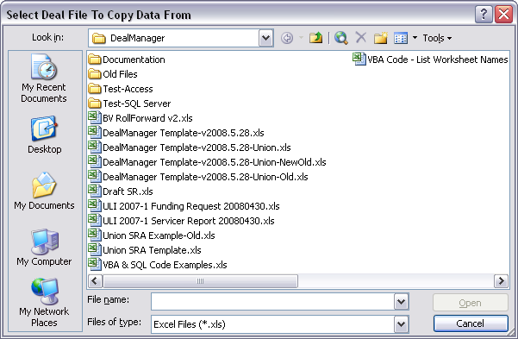

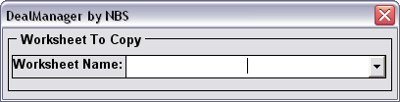

Insert Existing Report Worksheet, If Any
In most cases, the user has an existing Report or other Deal data worksheet that is to be used as the starting point for the SR process. The simplest way to insert this worksheet into the SR is to cut and paste it from another Excel file. This process is automated for you when you click the “Copy In Deal Data” button. Doing this will open the file dialog box where you can select the file from which to copy the data worksheet (see images above).

You can also manually cut and paste Deal data from a Word document or other form of text file. If not already in any other digital file format, you'll need to manually type in your Deal data.

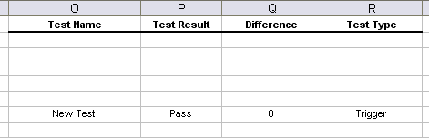

Deal Test Columns In Report Worksheet
After your Deal data is inserted into the “Report” worksheet, four Deal Test columns (Test Name, Test Result, Difference & Test Type) are automatically inserted to the right of your right-most data column in the “Report” worksheet (see image above). This occurs when you first click one of the DM toolbar buttons. These columns are used to store the Deal Test formulas and results.

Format Custom Worksheets
In certain cases for specific users [Union], Data Reports created in DM require custom formatting after the new Report opens up in Excel. Click “Format Custom Worksheets” to accomplish this process.

Report Settings
The Report Settings worksheet stores various values that control how the Deal data is organized.

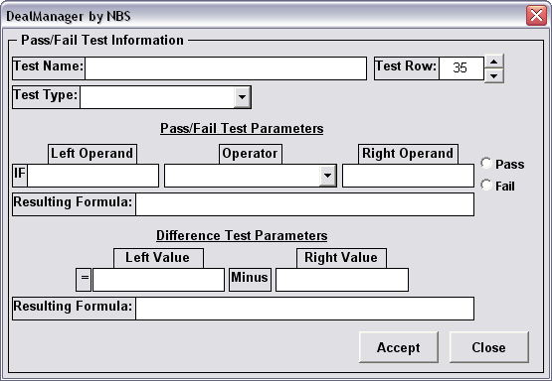

Configure Deal Tests
Select any cell on the “Report” worksheet, and then click the “Define/Modify Deal Tests” button to add or modify the deal test in that worksheet row. This will cause a form to open that lets you configure the various Deal Tests by naming the Deal Test, defining the type of value, the value and a measurement that indicates “Pass” or “Fail” (see image above). This information will be loaded into the DMDB each period. Once these values are loaded into the DMDB, the user can view the results through the DM interface. See Define Deal Tests above.

“Pass/Fail” Deal Tests are created/modified by first entering/editing a Test Name and then selecting a Test Type. Next, the Left & Right Operands are entered/edited by selecting the blank beneath each and then selecting the appropriate worksheet cell. After this, select an Operator from the drop-down list and then indicate Pass/Fail on the right-hand side of the form.

“Difference” Deal Tests are similarly created/modified by selecting Left & Right Values in the same manner as the Left & Right Operands are selected as described above.

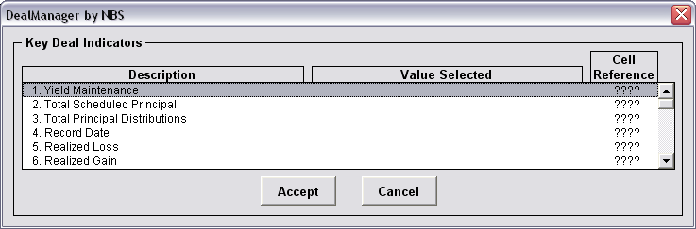

Configure Key Deal Indicators
These values are mapped in the SR application as part of the setup process and then are automatically updated in the DMDB each time a Trial or Final Report is generated. The user can then create Reports that analyze historical changes in each KDI and/or compare values to one another across different Deals.

Select any cell on the “Report” worksheet, and then click “Define Key Deal Indicators” to map deal data to the corresponding Key Deal Indicators (KDI). This will cause a form to open that lets you configure the KDIs by defining the value and cell reference for each (see image above). KDI values are selected by selecting a KDI from the form list and then selecting the appropriate worksheet cell.

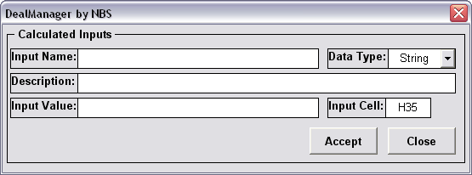

Configure Calculated Inputs
Calculated Inputs are not presented in the DM Deal Tests form, but are instead stored in the InputValues table and included in the data extract created for any SR. These values are used in SR calculations and to validate beginning balances (e.g., the beginning balance of all Securitized values should equal the ending balance that was captured and stored in the DMDB at the end of the prior period). These values are used in the SR in situations where the Deal requires a calculated result based on an average of 3-4 months of balances. For instance, it’s common to have a Default test based on the average default rate over the preceding three months. To perform this calculation, you need to know what the Defaults and Recoveries were for each of the preceding three months. To accommodate this requirement, the user can include the current Default and Recovery metrics as a “Calculated Input”, so that it’s captured and stored in the DMDB each period.

Select any cell on the “Report” worksheet, and then click “Define Calculated Inputs” (CI) to map Deal data to be uploaded to the DMDB. CI values are selected by selecting a cell from the “Report” worksheet."

Check For Deal Test Formula Errors
Click the “Check For Formula Errors” button to review the “Error Log” worksheet for Deal Test formula errors in the “Report” worksheet. These will need to be corrected in the “Report” worksheet before the Deal Test data can be uploaded into the DMDB.

Check For Deal Test Violations
Click the “Check For Deal Violations” button to review the “Error Log” worksheet for Deal Test result violations in the “Report” worksheet. These will need to be corrected in the “Report” worksheet before the Deal Test data can be uploaded into the DMDB.

Update “Tests” Worksheet
Click the “Update Tests Worksheet” button to copy all Deal Tests data to the “Tests” worksheet in preparation for uploading to the DMDB.

Upload Deal Test Data To DMDB
Click the “Upload Test Data to DM” button to upload all Deal Tests data to the DMDB.

Upload KDI & CI Data To DMDB
Click the “Upload KDI & CI Data to DM” button to upload all KDI and CI data to the DMDB.

Create Trial Report
This button creates the Trial Report by copying the deal information on the “Report” worksheet into a new workbook file, retaining all formulas and links.

Create Final Report
This button creates the Final Report by copying the deal information on the “Report” worksheet into a new workbook file, but retaining just the values and not any formulas or links.

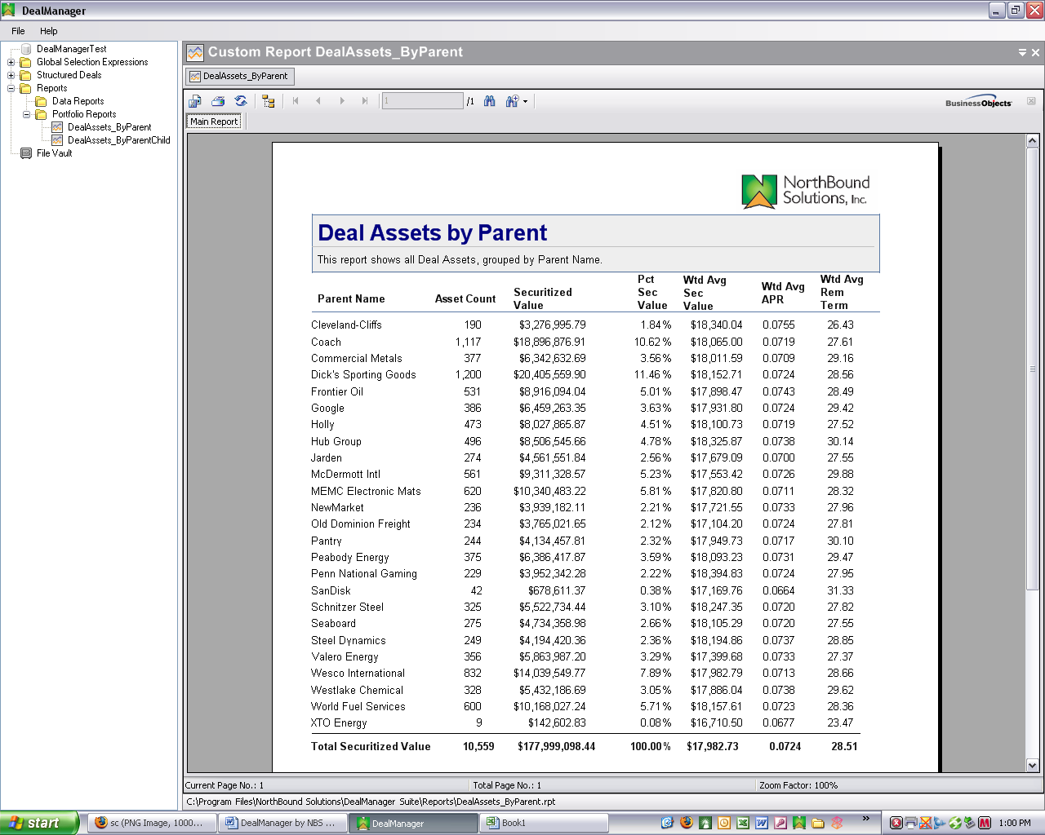

DM Reports

Standard Reports
As mentioned above in the Standard and Custom Report Engine section, the DM application uses Crystal Reports as the formal Report viewer. DM comes with two (so far) standard Reports, that can be viewed “as-is” from within DM or may be modified to suit the user’s unique business requirements.

Custom Reports
Additional custom reports can be created by the user in Crystal Reports and also viewed in DM. To create and view such custom reports, the user must simply place the .rpt files in a folder within the NorthBound DealManager Suite folder in the user’s Program Files folder.

Standard Portfolio Reports

View Portfolio Reports
The two included report forms are DealAssets_ByParent and DealAssets_ByParentChild. The DealAssets_ByParent Report contains the following seven columns of data: Parent Name, Asset Count, Securitized Value, Pct Sec Value, Wtd Avg Sec Value, Wtd Avg APR and Wtd Avg Rem Term. The DealAssets_ByParentChild has the same seven columns, but groups the data by Parent company, displaying the Child components as well.

To generate either of the Portfolio Reports, expand the “Reports” folder and the “Portfolio Reports” subfolder, right-click on one of the two aforementioned Report items and select “View” (or simply double-click on one of the Report items). After doing this, the selected Report will open in the right window pane (see image above). [NEED FULL DESCRIPTION OF CRYSTAL REPORTS VIEW/EDIT OPTIONS HERE]

Refresh Portfolio Reports
To refresh both of the Portfolio Reports, expand the “Reports” folder, right-click on the “Portfolio Reports” subfolder and select “Refresh”.

Data Reports and File Vault
To assist the user in storing Deal documents that may be used by multiple Deals, the DM application also contains Data Reports and File Vault folders separate from the Deal-speicific folders of the same names described above. [NEED FULL DESCRIPTION HERE]

APPENDICES

Appendix 1 – High Level Architecture

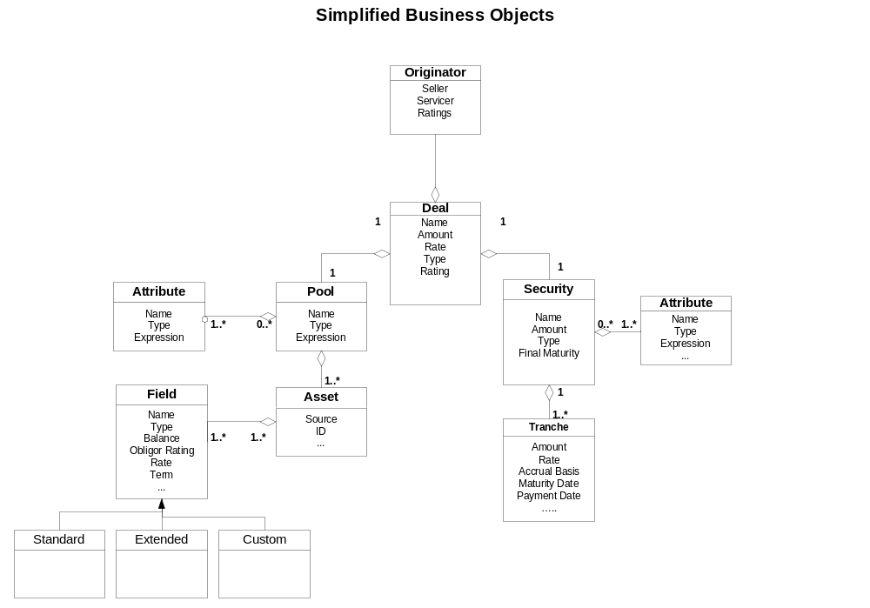

Appendix 2 – Terms and Definitions

- Asset: A financial obligation, typically a loan or lease, that is characterized by a number of different elements. Assets are held as collateral to back the Securitization or Structured Finance transaction. The most recent information about each Asset is represented in the Assets table while historical information about each Asset is retained in the AssetHistory table. The collection of all Assets in the Assets table general represents that entire portfolio of each customer.

- Deal: A Securitization or Structured Finance transaction, containing a set of business rules, required reports and workflow. Assets are associated with a Deal via a Pool, which is a collection of Assets that meets all Criteria for the current period.

- Pool: A collection of Assets that is created using a process to evaluate all Free Assets in the Assets table and determine a maximum amount of Assets that can be collected into a Pool, while complying with all Criteria defined by the user.

- Criteria: Limitations, filters or rules that define the composition of an acceptable Pool of assets for a given Deal. The criteria for a Deal can be modified by the user over time and all changes are retained in the database for reporting and auditing purposes.

- Free Assets: Assets that are not associated with any Active Pools for any Deal.

- Active Pool: A Pool that the user has formally committed to the Deal. Assets can only be in one Active Pool at a time, but can be in any number of Inactive Pools.

- Inactive Pool: A Pool that has been created but has not by formally committed to the Deal.

Appendix 3 – Standard Asset Expressions
[INSERT DESCRIPTIONS FOR ALL]

- ABS Indicator is true: xxx
- Is Active Lease: xxx
- Is Closed End: xxx
- Is Fixed Rate: xxx
- Is Floating Rate: xxx
- Is Government: xxx
- Is open-ended or Navy: xxx
- Lease Length: xxx
- Limit certain NR exposures: xxx
- No Delinquent Accounts: xxx
- Not driven in PR: xxx
- Parent ID Exclusion: xxx
- Ripe Asset: xxx
- Securitized Value Floor: xxx
- Trust Vehicle: xxx

Appendix 4 – Listed Database Fields
[INSERT DESCRIPTIONS FOR ALL]

- ABSGovernment_Ind: xxx
- ABSTrust_Ind: xxx
- AccBookDepr: xxx
- AsOfDt: xxx
- AssetStatus: xxx
- AvgDepreciationRatePct: xxx
- BookValue: xxx
- CapitalCost: xxx
- ChildId: xxx
- ChildName: xxx
- ClosedOpenInd: xxx
- CollateralId: xxx
- CollateralMake: xxx
- CollateralModel: xxx
- CollateralYear: xxx
- ContractDt: xxx
- ContractResidualAmt: xxx
- DeliveryDt: xxx
- DepreciationRatePct: xxx
- DriverSt: xxx
- EffectiveInterestRate: xxx
- FixedFloatInd: xxx
- GrossSaleAmt: xxx
- Id: xxx
- IndustryCode: xxx
- InsertDate: xxx
- LastInvoiceRunDt: xxx
- LeaseId: Lease identification number.
- LeaseTypeCd: xxx
- LeaseTypeDesc: xxx
- MonthInServiceMos: xxx
- MonthlyDepr: xxx
- NetSaleAmt: xxx
- OriginalTermMos: xxx
- ParentId: Parent ID number
- ParentName: Name of Parent
- PastDue_0_30: Accounts that are current
- PastDue_121_Over: Accounts past due over 120 days
- PastDue_31_60: Accounts past due at least 31 and less than 60 days
- PastDue_61_90: Accounts past due at least 61 and less than 90 days
- PastDue_91_120: Accounts past due at least 91 and less than 120 days
- PrimeRate: xxx
- ProgramCode: xxx
- RegSt: xxx
- RemTerm: xxx
- ReserveRatePct: xxx
- SecuritizedValue: xxx
- SoldDt: xxx
- SP_Rating: xxx
- StatedInterestRate: xxx
- TermDt: xxx
- Trust_Ind: xxx
- VehicleType: Vehicle model name
- VIN: Vehicle ID Number

Appendix 5 – Standard Custom Concentration Expressions
[INSERT LIST & DESCRIPTIONS FOR ALL]

- S&P Concentration Limit: xxx
- xxx:
- xxx:
- xxx:
- xxx:
- xxx:
- xxx:
- xxx:
- xxx:
- xxx:

Appendix 6 – Data Elements

- DealID: Deal identifier
- Name: Deal name
- CriterionCollectionID: [Need this one?]
- InitialAmt: Initial note amount
- CollateralInitialAmt: Initial collateral amount
- SecuritizedValue: Amount of collateral, based on Deal definitions
- IssueTypeID: Type of Securitization transaction (US Public, Non-US, US MBS, US 144A Private or CDO)
- StructureTypeID: Type of Securitization structure (Grantor trust, FASIT, Owner Trust, etc.)
- CloseDt: Date the transaction closed
- FinalMatDt: Legal final maturity date of the transaction
- RecDt: [Receipt] date of the transaction
- PricingDt: Pricing date of the transaction
- Issuer: Name of the Issuer
- Transferor: Name of the Transferor
- Underwriter: Name of the Underwriter
- Originator: Name of the Originator
- UWCounsel: Name of the legal counsel for the Underwriter
- IssCounsel: Name of the legal counsel for the Issuer
- Trustee: Name of the Trustee
- Currency: Currency type
- CollType: Collateral type
- CollCurrency: Collateral currency
- DealEnhancementTypeID: Deal enhancement type (reserves, over-collateralization, etc.)
- SellerRating: Seller rating
- SellerType: Seller type
- InitialAssetsCount: Count of assets in the initial Pool
- InitialCollateralWAM: Weighted average maturity of the initial Pool
- InitialValueofAssets: Total Securitized value of the initial Pool
- InitialCollateralWAC: Weighted average coupon of the initial Pool

